

|  |  |  |  |  |
| --- | --- | --- | --- | --- |
| STUDENT DETAILS | | | | |
| Applying for Year:  7  8  9  10  11  12 | | | Commencing in:  2025  2026  2027 | |
| Surname: | | | | |
| First Name: | | Second Name: | | |
| Preferred first name: | | | | |
| Date of birth: | Age: | | | Religion: |
| Gender:  Male  Female  Non-binary | | | | |
| Current school: | | | | |
| Foundation/Prep school attended: | | | | |
| Commencement year of Foundation/Prep: | | | | |

***Students are enrolled under the name on their birth certificate. A copy of birth certificate MUST be provided.***

|  |  |  |
| --- | --- | --- |
| HOME ADDRESS OF STUDENT | | |
| Street number & name: | | |
| Suburb: | State: | Postcode: |

|  |
| --- |
| ENROLMENT POLICY |
| Priority of enrolment is given to:   * Catholic children * Students attending St Mary’s Ararat and St Patrick’s Stawell Primary Schools * Students who are presently attending Catholic schools in other areas * Siblings of current or past students of Marian College |

|  |
| --- |
| REQUIRMENTS FOR APPLICATION |
| Copy of child’s birth certificate  Copy of last issued school report  Copy of your child’s NAPLAN results  Copies of sacramental certificates (Catholic only)  Copy of child’s passport Visa if born outside of Australia or not an Australian Citizen  Please make sure that all sections of this application are complete and return to:  The Registrar  Marian College Ararat  PO Box 314  Ararat VIC 3377 |

|  |  |  |
| --- | --- | --- |
| NATIONALITY (GOVERNEMENT REQUIRMENTS) | | |
| Nationality: | | Ethnicity: |
| Country of birth  Australia  Other (please specify): | | |
| Place of birth: | | |
| Citizenship Status (select one)  Australian Citizen  Exchange Student  Refugee  Permanent Resident  Temporary Resident | | |
| Is the student of Aboriginal or Torres Strait Islander origin?  Aboriginal  Torres Strait Islander  Both Aboriginal & TSI  Neither Aboriginal or TSI | Does the student speak a language other than English at home?  English only  Other (please specify)  _______________________ | |

|  |  |  |  |
| --- | --- | --- | --- |
| VISA DETAILS (for students not born in Australia. Copies must be provided) | | | |
| Date arrived in Australia: | | | |
| Nationality of Passport: | | Passport number: | |
| Passport expiry: | Visa Sub Class Number: | | Visa expiry: |
| First Australian School attended: | | | |
| Commencement date: | | | |
| Has the student studies an EAL program or received addition support for language?  Yes  No | | | |

|  |  |  |
| --- | --- | --- |
| SACRAMENTAL INFORMATION (Catholic students only) | | |
| Baptism | Date: | Parish: |
| Confirmation | Date: | Parish: |
| Reconciliation | Date: | Parish: |
| Communion | Date: | Parish: |

|  |  |  |
| --- | --- | --- |
| FAMILY | | |
| Rank in family: 1 of | Boys: Girls: |  |
| Siblings attending Marian College (including past students and years attended)  _______________________________________ 20____ ____________________________________________ 20____  _______________________________________ 20____ ____________________________________________ 20____ | | |
| Future enrolments (please note that this is not a formal enrolment and that you are required to undertake this enrolment process for all siblings)  _______________________________________ 20____ ____________________________________________ 20____  _______________________________________ 20____ ____________________________________________ 20____ | | |

|  |  |  |  |  |  |
| --- | --- | --- | --- | --- | --- |
| MEDICAL INFORMATION | | | | | |
| Doctor’s Name: | | | | | |
| Practice Name: | | | | | |
| Practice Address: | | | | | |
| Suburb: | Postcode: | | | Phone: | |
| Medicare number: | | | Ref: | | Expiry: |
| Private health insurance  Yes  No | | | Fund: | | Number: |
| Ambulance cover  Yes  No | | Number: | | |  |
| Health care card  Yes  No | | Number: | | | Expiry: |
| Other concession card type: | | | | | |

|  |
| --- |
| MEDICAL CONDITIONS |
| **Anaphylaxis** – if your child suffers from anaphylaxis, a completed Anaphylaxis Action Plan with your child’s most recent photo is required with this application. Ministerial Order 706 – Anaphylaxis.  **Asthma –** If your child suffers from asthma, a completed Asthma Action Plan with your child’s most recent photo is required with this application. This includes the type, name and dosage of the medication your child uses for asthma.  Has your child experienced any of the following conditions?  Anaphylaxis  Asthma  Diabetes  Food allergies  Epilepsy  Insect allergy  Haemophilia  Migraine  Dietary needs  Allergy to medication  Sight loss  Hearing loss  Recurring injury  Glandular Fever  Takes prescribed medication on a regular basis  Other: _________________________________    Details:  If you have ticked any of the above, please provide further details  ________________________________________________________________________________________________________________________________________________________________________________________________________________________________________________________________________________________________________________________________________________________________________________________________________________________________________________________________________________________________________________________________________________________________________________________________________________________________________________________________ |

|  |
| --- |
| ADDITIONAL NEEDS |
| Is your child eligible or currently receiving National Disability Insurance Scheme (NDIS) support?  Yes  No |
| Does your child present with:  ASD  ADD/ADHD  Anxiety  Physical Impairment  Behavioural concerns  Mental Health Issues  Severe Language Disorder  Intellectual disability  Details:  If you have ticked any of the above, please provide further details. Supporting documents must be provided.  _______________________________________________________________________________________________________________________________________________________________________________________________________________________________________________________________ |

|  |
| --- |
| SPECIALIST SERVICES |
| Has your child ever seen a?  Psychiatrist  Psychologist  Counsellor  Occupational Therapist  Speech Therapist  Optometrist  Paediatrician  Other: _________________________  Details:  If you have ticked any of the above, please provide further details. Supporting documents must be provided.  ________________________________________________________________________________________________________________________________________________________________________________________________________________________________________________________________________________________________________________________________ |

|  |
| --- |
| ACADEMIC |
| Marian College caters for the needs of all students and is able to adapt a specially designed and individual academic program to suit each student.  If the answer is ‘yes’ to any of the below, please provide a copy of documentation with this application. This information will assist the Learning Diversity Team to provide further testing, tailored programs and funding applications to enhance your child’s learning.  *This has no impact on your child’s application and all information is kept in the strictest confidence.*  Does your child receive additional support?  Yes  No  Has your child ever been tested regarding learning needs?  Yes  No  Has your child been involved in extension programs?  Yes  No  Has your child participated in special literacy or numeracy programs?  Yes  No |

|  |
| --- |
| ACADEMIC |
| How would you describe your child’s ability to cope with school/class work?  ________________________________________________________________________________________________________________________________________________________________________________________________________________________________________________________________  How would you describe your child’s ability to cope with home study?  ________________________________________________________________________________________________________________________________________________________________________________________________________________________________________________________________  How would you describe your child’s ability to cope with socialisation with their peers?  ________________________________________________________________________________________________________________________________________________________________________________________________________________________________________________________________  Do we need to be aware of any specific health/social/emotional needs of your child?   1. In the classroom   ___________________________________________________________________________________________________________________________________________________________________________   1. On excursion or camps   ___________________________________________________________________________________________________________________________________________________________________________ |

|  |  |  |  |
| --- | --- | --- | --- |
| HOME CARE ARRANGEMENTS | | | |
| Live with parents at home |  | Joint custody/shared parenting:  Days with Parent A: ____  Days with Parent B: ____ |  |
| Mother only at home |  | Father only at home |  |
| Mother and partner at home |  | Father and partner at home |  |
| Lives with Grandparents |  | Lives with carer/Guardian |  |
| Out-of-home care |  | Kinship care |  |
| Independent Student |  | Lives with host family |  |
| Other (please specify): | | | |

|  |  |  |  |  |  |  |  |  |  |  |  |  |
| --- | --- | --- | --- | --- | --- | --- | --- | --- | --- | --- | --- | --- |
| PARENT A or GUARDIAN 1 | | | | | | | | | | | | |
| Title: Dr Mr Mrs Ms Miss | | | Relationship to student: | | | | | | | | | |
| First Name: Surname: | | | | | | | | | | | | |
| Residential Address: | | | | | | | | | | | | |
| Suburb: | | | | | State: | | | | | Postcode: | | |
| Postal Address: | | | | | | | | | | | | |
| Suburb: | | | | | | State: | | | | | Postcode: | |
| Home phone: | | Work phone: | | | | | | | Mobile: | | | |
| Email: | | | | | | | | | | | | |
| Country of birth: Australia Other (please specify): | | | | | | | | | | | | |
| Nationality: | | | | | | Ethnicity (if born outside of Australia): | | | | | | |
| Occupation: | | | | | | Employer: | | | | | | |
| What is the occupation group?  select from list of School Family Occupation Index | | | |  | | | | Centrelink payments  Yes  No | | | | |
| Religion: | | | | |
| **Highest level of high school complete (please circle one)** | | | | | | | | | | | | |
| Year 9 or below | Year 10 or equivalent | | | | | | Year 11 or equivalent | | | | | Year 12 of equivalent |
| **Highest qualification completed (please circle one)** | | | | | | | | | | | | |
| No post school  qualifications | Certificate I to IV  (including trade certificates) | | | | | | | Advanced diploma or diploma | | | | Bachelor degree or above |
| PARENT A or GUARDIAN 1 | | | | | | | | | | | | |
| Title: Dr Mr Mrs Ms Miss | | | Relationship to student: | | | | | | | | | |
| First Name: Surname: | | | | | | | | | | | | |
| Residential Address: | | | | | | | | | | | | |
| Suburb: | | | | | State: | | | | | Postcode: | | |
| Postal Address: | | | | | | | | | | | | |
| Suburb: | | | | | | State: | | | | | Postcode: | |
| Home phone: | | Work phone: | | | | | | | Mobile: | | | |
| Email: | | | | | | | | | | | | |
| Country of birth: Australia Other (please specify): | | | | | | | | | | | | |
| Nationality: | | | | | | Ethnicity (if born outside of Australia): | | | | | | |
| Occupation: | | | | | | Employer: | | | | | | |
| What is the occupation group?  select from list of School Family Occupation Index | | | |  | | | | Centrelink payments  Yes  No | | | | |
| Religion: | | | | |
| **Highest level of high school complete (please circle one)** | | | | | | | | | | | | |
| Year 9 or below | Year 10 or equivalent | | | | | | Year 11 or equivalent | | | | | Year 12 of equivalent |
| **Highest qualification completed (please circle one)** | | | | | | | | | | | | |
| No post school  qualifications | Certificate I to IV  (including trade certificates) | | | | | | | Advanced diploma or diploma | | | | Bachelor degree or above |

|  |  |  |  |  |  |  |  |  |  |  |  |  |
| --- | --- | --- | --- | --- | --- | --- | --- | --- | --- | --- | --- | --- |
| STEP – PARENT OR OTHER LEGAL GUARDIAN | | | | | | | | | | | | |
| Title: Dr Mr Mrs Ms Miss | | | Relationship to student: | | | | | | | | | |
| First Name: Surname: | | | | | | | | | | | | |
| Residential Address: | | | | | | | | | | | | |
| Suburb: | | | | | State: | | | | | Postcode: | | |
| Postal Address: | | | | | | | | | | | | |
| Suburb: | | | | | | State: | | | | | Postcode: | |
| Home phone: | | Work phone: | | | | | | | Mobile: | | | |
| Email: | | | | | | | | | | | | |
| Country of birth: Australia Other (please specify): | | | | | | | | | | | | |
| Nationality: | | | | | | Ethnicity (if born outside of Australia): | | | | | | |
| Occupation: | | | | | | Employer: | | | | | | |
| What is the occupation group?  select from list of School Family Occupation Index | | | |  | | | | Centrelink payments  Yes  No | | | | |
| Religion: | | | | |
| **Highest level of high school complete (please circle one)** | | | | | | | | | | | | |
| Year 9 or below | Year 10 or equivalent | | | | | | Year 11 or equivalent | | | | | Year 12 of equivalent |
| **Highest qualification completed (please circle one)** | | | | | | | | | | | | |
| No post school  qualifications | Certificate I to IV  (including trade certificates) | | | | | | | Advanced diploma or diploma | | | | Bachelor degree or above |
| STEP – PARENT OR OTHER LEGAL GUARDIAN | | | | | | | | | | | | |
| Title: Dr Mr Mrs Ms Miss | | | Relationship to student: | | | | | | | | | |
| First Name: Surname: | | | | | | | | | | | | |
| Residential Address: | | | | | | | | | | | | |
| Suburb: | | | | | State: | | | | | Postcode: | | |
| Postal Address: | | | | | | | | | | | | |
| Suburb: | | | | | | State: | | | | | Postcode: | |
| Home phone: | | Work phone: | | | | | | | Mobile: | | | |
| Email: | | | | | | | | | | | | |
| Country of birth: Australia Other (please specify): | | | | | | | | | | | | |
| Nationality: | | | | | | Ethnicity (if born outside of Australia): | | | | | | |
| Occupation: | | | | | | Employer: | | | | | | |
| What is the occupation group?  select from list of School Family Occupation Index | | | |  | | | | Centrelink payments  Yes  No | | | | |
| Religion: | | | | |
| **Highest level of high school complete (please circle one)** | | | | | | | | | | | | |
| Year 9 or below | Year 10 or equivalent | | | | | | Year 11 or equivalent | | | | | Year 12 of equivalent |
| **Highest qualification completed (please circle one)** | | | | | | | | | | | | |
| No post school  qualifications | Certificate I to IV  (including trade certificates) | | | | | | | Advanced diploma or diploma | | | | Bachelor degree or above |

|  |
| --- |
| EMERGENCY CONTACTS |
| *PLEASE NOTE: The emergency contact is NOT someone already listed in this application. Only emergency contacts that are listed will have permission to take the student from the College, unless otherwise advised by phone call or written permission. Please ensure that you provide emergency contacts from the local area, as they must be able to collect the student if required.* |

|  |  |  |  |  |  |
| --- | --- | --- | --- | --- | --- |
| EMERGENCY CONTACT 1 | | | | | |
| Title: Dr Mr Mrs Ms Miss | | Relationship to student: | | | |
| First Name: Surname: | | | | | |
| Residential Address: | | | | | |
| Suburb: | | | State: | | Postcode: |
| Home phone: | Work phone: | | | Mobile: | |
| Country of birth: Australia Other (please specify): | | | | | |
| Religion: | | | | | |

|  |  |  |  |  |  |
| --- | --- | --- | --- | --- | --- |
| EMERGENCY CONTACT 2 | | | | | |
| Title: Dr Mr Mrs Ms Miss | | Relationship to student: | | | |
| First Name: Surname: | | | | | |
| Residential Address: | | | | | |
| Suburb: | | | State: | | Postcode: |
| Home phone: | Work phone: | | | Mobile: | |
| Country of birth: Australia Other (please specify): | | | | | |
| Religion: | | | | | |

|  |
| --- |
| COURT ORDERS OR PARENTING ORDERS (if applicable) |
| Are there any current court orders or parenting orders relating to the student?  Yes  No  *If yes, copies of these court orders/parenting orders (e.g. AVOs, Family Court/Federal Magistrates Court orders or other relevant court order* ***must*** *be provided.*  Is there any other information you wish the school to be aware of?  ____________________________________________________________________________________________________________________________________________________________________________________________________________________________________________________________________________________________________ |

|  |  |  |  |
| --- | --- | --- | --- |
| TUITION FEES & CHARGES ARRANGEMENTS | | | |
| I/We, the undersigned, agree to pay the approved school fees each year in accordance with the following:   * The approved fees are to be paid in full within 30 days of request (unless otherwise agreed). * The obligation of 2 or more fee payers to pay the approved fees is joint and several for 100% of the fees, unless agreed otherwise with the College.   Approved fees mean the annual fees as set by the College each year covering all compulsory charges.   * Any changes to the designated fee payer/s listed on the Enrolment Application must be submitted to the College in writing, signed by all interested parties. Failure to make such an arrangement could result in contact with a Debt Collection Agency. * If circumstances should arise to alter our ability to adhere to the above, we agree to contact the Principal or Business Manager.   In accordance with the yearly fees and charges schedule, I/We understand that fee payments are due each team, over the first three terms, or as an annual payment due in accordance with the current fee schedule. I/We understand that arranges can be made to pay fees by instalments on a weekly, fortnightly or monthly basis by contacting the Business Manager.  **I/We agree to pay  By instalments  Per term  Annually**  If any circumstances should arise to alter our ability to adhere to the above, we agree to contact the Principal or Business Manager.  **I/We have read, clearly understand and agreed to all conditions in this Enrolment Agreement.** | | | |
| **Print Name** |  | **Signature** |  |
| **Print Name** |  | **Signature** |  |

|  |  |  |  |  |  |  |  |  |
| --- | --- | --- | --- | --- | --- | --- | --- | --- |
| SPLIT/SEPARATED FAMILIES  (for separated or mixed families where the fee is shared and each fee payer charged separately). Percentages must total 100% | | | | | | | | |
| Print Name |  | | Signature | |  | | Fee Percentage |  |
| Print Name |  | | Signature | |  | | Fee Percentage |  |
|  | | | | | | | Total | 100% |
| In accordance with the yearly fees and charges schedule, I/We understand that fee payments are due each term, over the first three terms, or as annual payment due in accordance with the current fee schedule. I/We understand that arrangements can be made to pay fees by instalments on weekly fortnightly or monthly basis by contacting the Business Manager. | | | | | | | | |
| Print Name  Fee payer 1 | |  | | Signature | |  | | |
| **I agree to pay  By instalments  Per term  Annually**  If any circumstances should arise to alter our ability to adhere to the above, we agree to contact the Principal or Business Manager.  I would like to receive the school newsletter?  Yes  No  I would like to receive school report?  Yes  No | | | | | | | | |
| Print Name  Fee payer 2 | |  | | Signature | |  | | |
| **I agree to pay  By instalments  Per term  Annually**  If any circumstances should arise to alter our ability to adhere to the above, we agree to contact the Principal or Business Manager.  I would like to receive the school newsletter?  Yes  No  I would like to receive school report?  Yes  No | | | | | | | | |

|  |
| --- |
| METHOD OF TRAVEL TO SCHOOL |
| Distance to school: ______ kilometres  Walk  Bicycle  Car  Ararat Town bus  Armstrong bus  Moyston bus    Elmhurst bus  Beaufort bus  Warrak bus  Willaura bus    Stawell/Great Western bus  Pomonal/Halls Gap bus  Via bus links - The bus service is subsidised by the State Government for those travelling to the Catholic school closest to their home address.  Through ***Christians Bus Co*** and in association with Ararat Secondary College, seven buses transport to and from Marian College.  Through ***Sandlants Bus Company*** we cater for Stawell, Halls Gap, Pomonal, Great Western & surroundings.  Parents/Guardians & Students **must** complete, sign and return the application forms including the Code of Conduct Declaration before travel can commence. These form can be found on our website under enrolment/transportation.  Will your child be travelling on a ***Sandlants Bus***?  Yes  No  If Yes, then you are required to completed the Student Conveyance Application available on our website under Enrolments/Transportation/Form 3 Public Transport Travel Sandlants.  Will your child travel by private vehicle more than 4.8km to the nearest ***Christians Bus*** stop?  Yes  No  If Yes, then you are required to complete the Private Car Application available on our website under Enrolments/Transportation/Private Car Travel. |



|  |  |  |
| --- | --- | --- |
| ENROLMENT AGREEMENT | | |
| Marian College embraces the mission of the Church by welcoming the enrolment of all students and families who share their vision and educational philosophy.  By signing this Enrolment Application Form, Parents/Guardians/Carers understand and agree to the following:   * Full payment of the school fees and other charges. * To respect and support the Catholic ethos, the Religious Education Program, values, regulations and policies of Marian College. * To ensure that all communication and correspondence with College staff is undertaken in a polite and respectful manner at all times. * To comply with all Marian College with conditions of attendance and to support the College’s policies as published on the Marian College website and in the Student Diary. * To comply with all Marian College requirements regarding general appearance, wearing the correct Marian College uniform with pride and avoiding extremes in hairstyles, colours and fashion. * To attend all timetabled classes including extracurricular activities such as Athletics and Swimming Carnivals, Camps and Retreats. * To pay all fees, levies and incidental costs as nominated when required. Should financial hardship prevent full payment of fees, contact must be made with the Business Manager or Principal. * To give permission for students to participate in any local excursions within the town boundaries organised by subject teacher with in school hours. * To complete the electronic SIMON permission requests to ensure medical information and health alerts are current.   This Enrolment Application Form is a legally binding document. Signing the form is your acceptance of the terms and conditions of the College which includes payment of the school fees. Please be aware that whoever signs the enrolment form is the person legally responsible. It is recommenced that regardless of marital status, both parents are to sign he form. **Unsigned forms will not be accepted.**  **The Principal reserves the right to cancel enrolments, in consultation with Kildare Education Ministries, of any student whose behaviour or influence in regarded as harmful to the interest of staff, other students and the Marian College Community.** | | |
| PARENTS/CARERS/GUARDIANS | | |
| SIGNATURE | NAME | DATE |
| SIGNATURE | NAME | DATE |

|  |
| --- |
| OFFICE USE ONLY |
| Interviewer: _____________________________________________________________  Interview Date: ___________  ________________________________________________________________________________________________________________________________________________________________________________________________________________________________________________________________________________________________________________________________________________________________________________________________________________________________________________________________________________________________________________________________________________________________________________________________________________________________________________________________________________________________________________________________________________________________________________________________________________________________________________________________________________________________________________________________________________________________________________________________________________________________________________________________________________________________________________________________________________________________________________________________________________________________________________________________________________________________________________________________________________________________________________________________________________________________________________________________________________________________________________________________________________________________________________________________________________________________________________________________________________________________________________________________________________________________________________________________________________________________________________________________________________________________________________________________________________________________________________________________________________________________________________________________________________________________________________________________ |

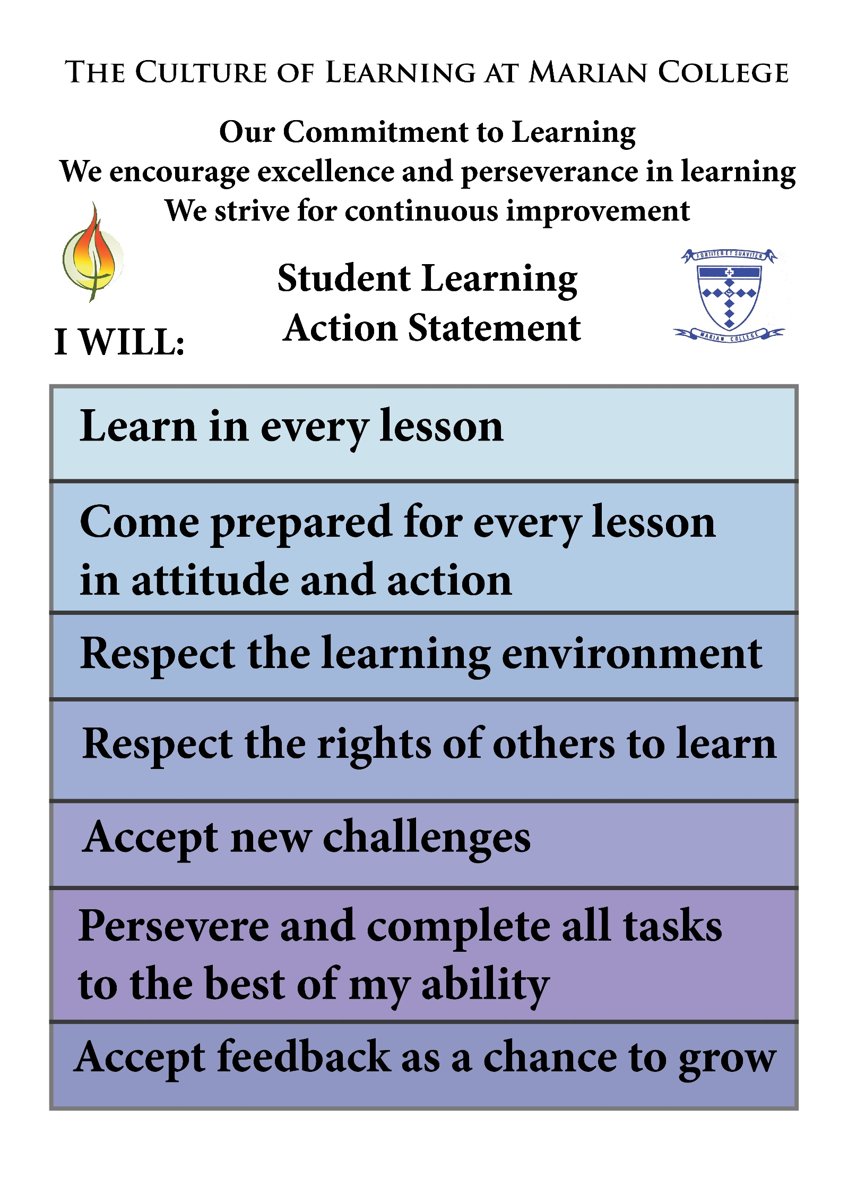

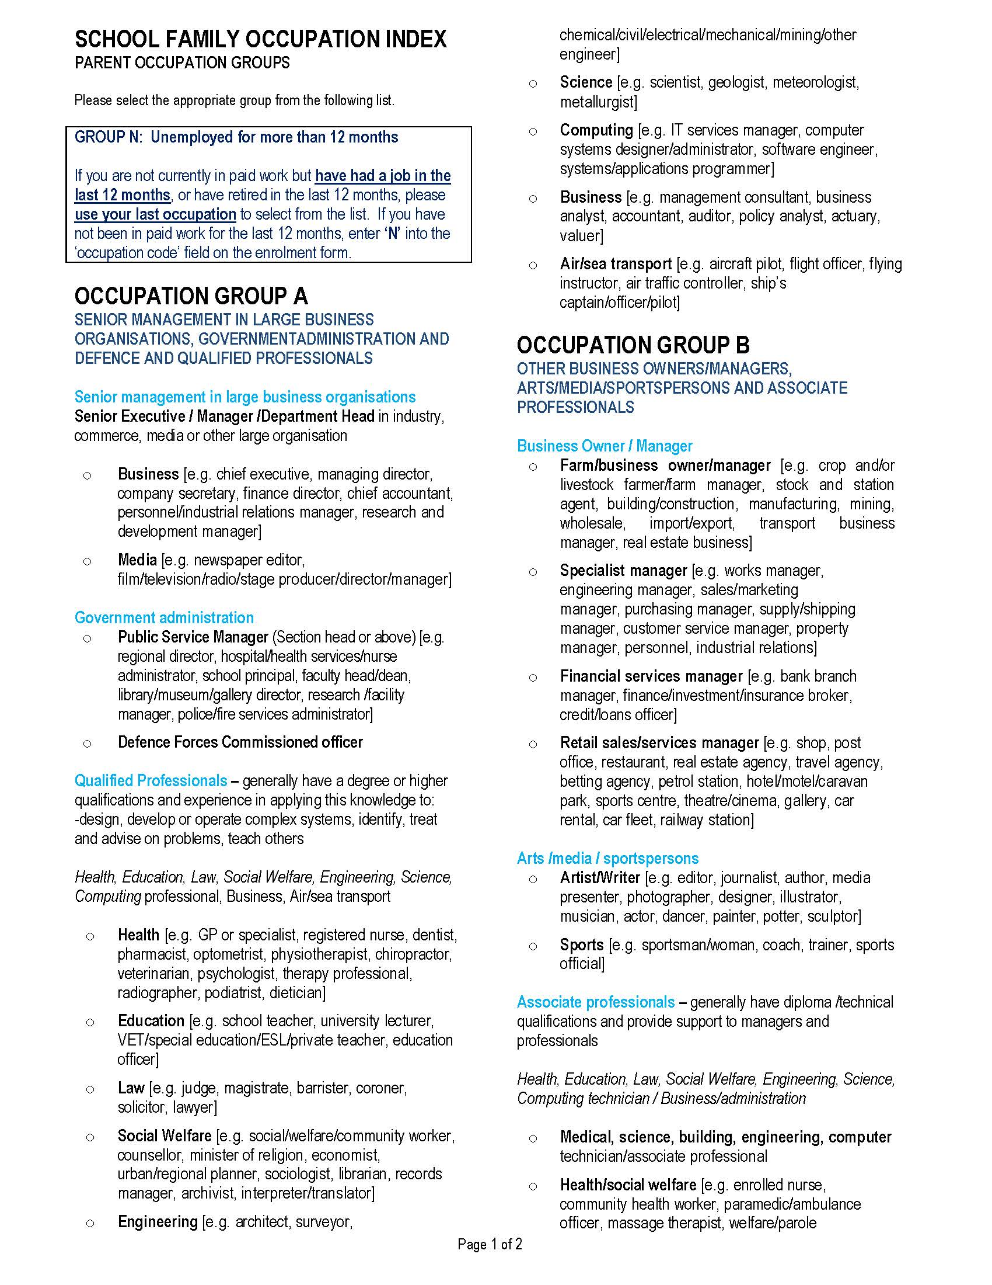

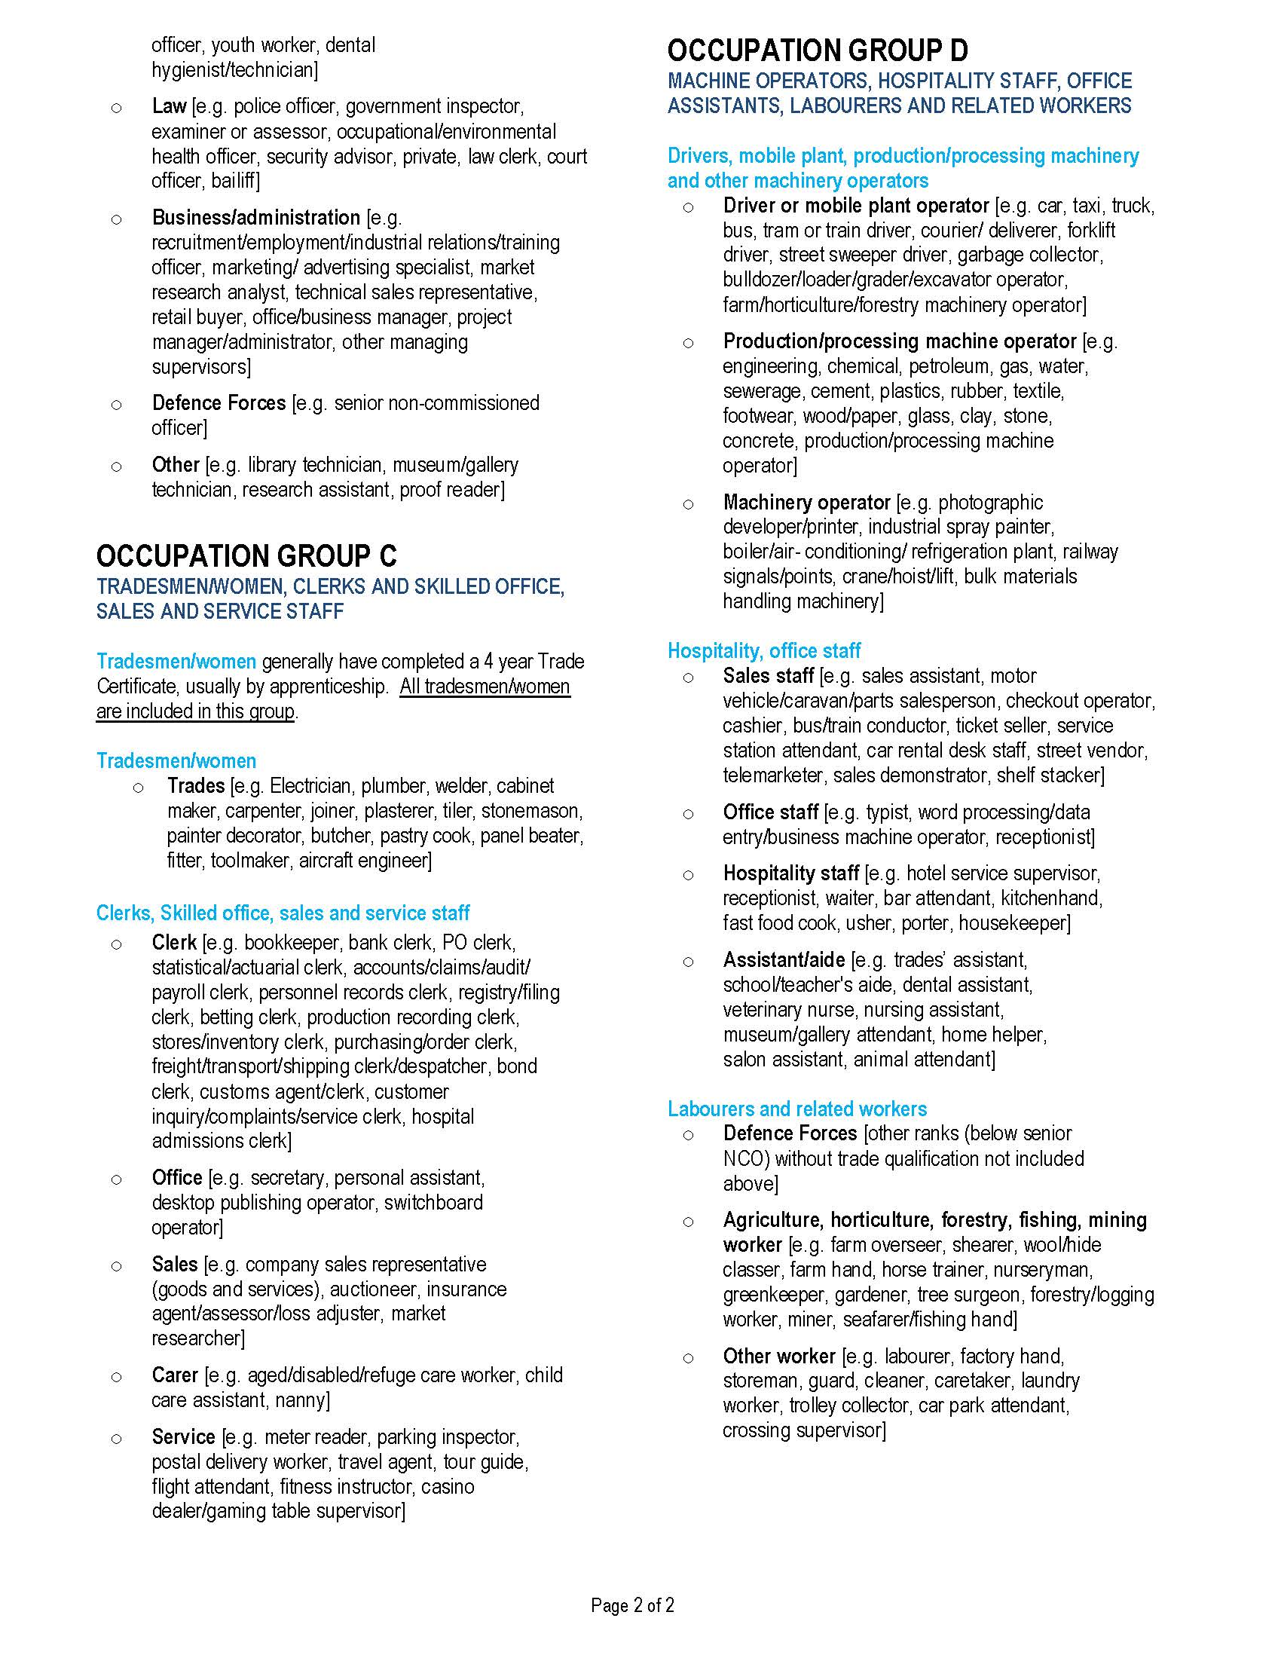

Strength and Gentleness.

We welcome all, especially the most vulnerable.

